Useful tools for busy principals
Ways you can use your computer to make your job easier (particularly using outlook and OneNote)

Presenters Mike Malcolm (Leamington School) mike@leamington.school.nz
Pat Poland (Deanwell) principal@deanwell.school.nz

Outline of session
Introduction
5 useful tips with how to use computer – 10 mins (Mike and Pat)
5 most useful things to do with OneNote – 30 mins (Pat)
5 most useful things to do with emails – 30 mins (Mike)

Format
- show you how we use it on computer
- Explain why we use it
- Give you time to set it up on your computer following simple instructions
- Discussion – 5 ways each person could use tools in your job

Note: the tools we are showing today are the tools we have found most useful in our practice. It is important to note that these save us a lot of time, but for some people they may not like to organize their computer tasks this way. There is no right way, there is a way you like the best. It is also important to note that with any new task, you have to allow yourself learning time. Initially you will be slow, then over time you will become proficient, automatic and time effective.

5 useful things to do with Computer
1 | Separate Computer screen – 19 inch or bigger | Having a separate screen to look at is essential for working in an office. These can be purchased from as little as $200. It makes working on the computer far easier on the eyes, and when used in Dual Desktop mode, far more efficient.
2 | Dual Desktop Mode | All windows computers can be made to use dual desktop mode. This has the effect of having two computers on your desk. Use one to look at one piece of information, the other (larger) screen to do your main work.  To activate dual screen in most cases, you can activate it by right mouse clicking on the desktop screen, and finding the output options associated with your display software.
3 | Wireless keyboard and Mouse | Using a wireless keyboard and mouse is a must. These can be purchased new from approx $100 from Dick Smith or any computer shop.
4 | Capture wiz pro | This extremely useful programme allows you take a photo of any image on the screen. You can then paste this image into word, powerpoint, publisher etc.  Alternatively, you can save the picture, email it, or make it a sticky on your screen.  This programme also allows you to take a movie of the screen, or record audio.  www.pixelmetrics.com  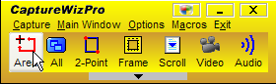
5 | Sync Toy (free) | By doing a quick search on the internet, you can download Synctoy.  This extremely useful programme allows you to back up your work quickly, and take backups of other peoples work.  Ways to use it  Backup all your work to an external hard drive  Backup the office files or financial information  Backup your work to the server

Email with outlook
1 | Create mail folders | Given the amount of emails principals receive, having folders to put mail into is vital. To create a mail folder, place your curosr over inbox, and right mouse click. Select New Folder and then give the folder a name.  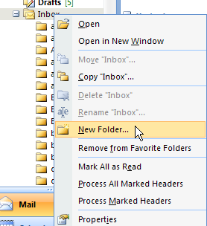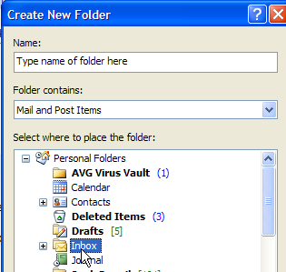  You can then drag emails from your inbox into the folders you have created.

2 | Making rules for mail messages to go into the folders automatically | Making rules for emails so they automatically go in the folder can save a lot of time and is useful to find emails people have sent you. To make a rule right mouse click on the message and select create rule.  Tick the “From” box and the “Move the item to folder” box.  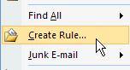  Make sure to select the folder you want the messages sent to.  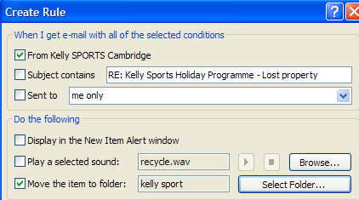  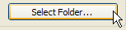  Once this rule has been created, the box below will appear. Select run this rule now on messages already in the folder. This will move all messages from that person into that folder.  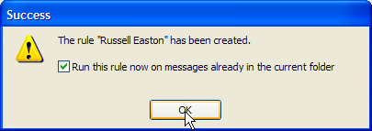  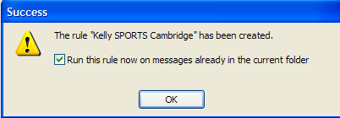
3 | Automatically send / receive | A handy thing to get outlook to do is to automatically chech your emails every few minutes.  In the mail section, click on the tools menu button and select options.  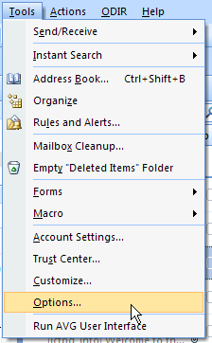  Then select Mail Setup  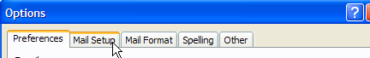  Then select Send/Receive  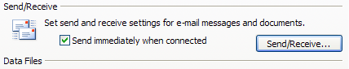  Then select how often you want outlook to check your emails. You can select it to check every minute if you want. I have mine set to 30 minutes, otherwise you get no work done cause there are always new emails arriving distracting you from the work you want to get done! When you are finished, click close.  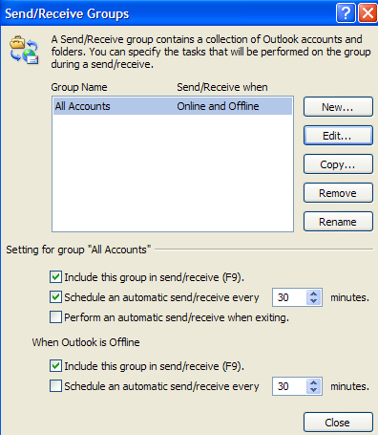
4 | Unread mail vs inbox | In the mail area, under seach folders at the bottom of the screen, is an unread mail option.  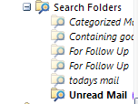  Drag this up to the Favourtie Folders section. Then, to read emails that you have not read yet, click on Unread mail. This then only show you emails you have not read, and as you read them, they get removed from your list!  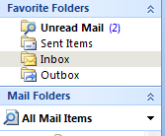
5 | Signatures | You can create a signatur to go out on the bottom of your emails. To do this the easy way, click on New to create a new email.  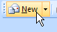  Then select Signatures from the top menu bar, and select signatures  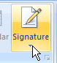  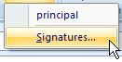  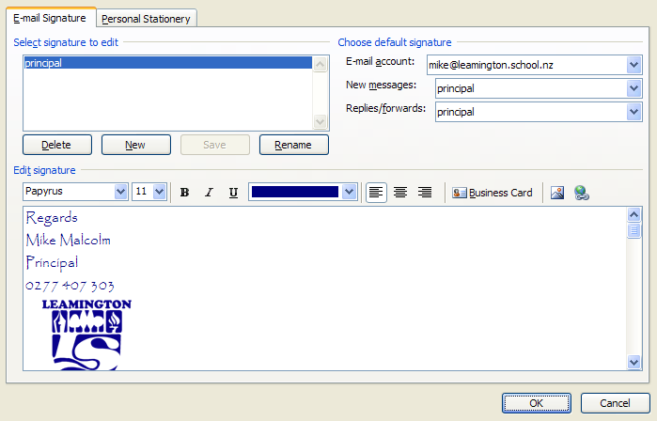  From here you can make a signature, with your name and contact details. You can also add your school logo.  Another idea is to add the logos of the people who sponsor your school newsletter and create a newsletter signature. Then, when you email out the newsletter, selct the newsletter signature. It allows you to increase the amount you charge for newsletter space, and it looks good!
6 | Reading pane | By selecting view, then reading pane, then right, you can see the email without having to open each one.  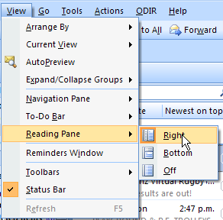
7 | Sending email options | When sending an email, there are a lot of options to use.  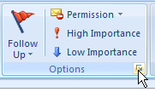  This will bring up the following options  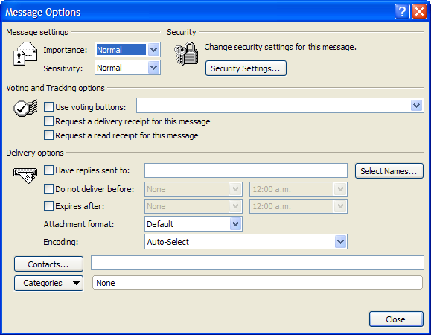  Here you can select if an email is important.  You can ask for a reply to be sent to you when the email is read, or ask for a delivery receipt.  I regularly use the “Do not delivery before:” option.  Ways to use this  You want to email someone to remind them of something in a week time. You can send it now and forget about it, knowing it will get there when you want it to.  Emailing birthday wishes ahead of time.  Forwarding an email to yourself that you don’t want to deal with now, and chose when you want to deal with it.  Sending a email, but you want time to think about what you have written before it goes into cyber space!
8 | Different address bar options | 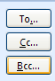to – everyone sees who is getting the email.  Cc… - carbon copy. These people get a copy of email. If the person replies, it does not automatically go to the CC person.  Bcc… - blind carbon copy. No one else sees who get the message. This is usefull for newsletter mail outs. It is also useful if you don’t want someone to use reply all and email back a comment to everyone that you emailed!
9 | Sending from different accounts | If outlook is configured to check multiple accounts, you can choose what account you want the email to come from. When writing an email, select account and choose what account you want to use to send the email.  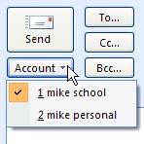
10 | Send an email to Onenote | If you get an email that you want to hold on to, or refer back to because of its importance, you can send it to onenote. A nice way to keep track of important emails and file them. You can also send emails with attachments, and the attachment is contained in onenote for you to open easily.
11 | Calendar beside emails | By selecting view, then “to do bar” and then selecting date navigator and appointments you can see your calendar, the month calendar, appointments and emails all on the same screen.  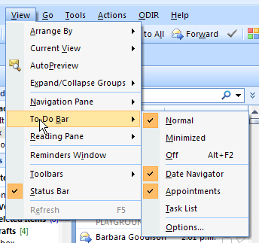

Calendar with outlook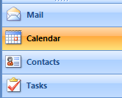

1 | Calendar | Chose between Day, week, or month view by clicking on each one. Show work week or Show full week allows you to see the weekend or Monday to Friday.
2 | Make an appointment / meeting | Double click on the space you want to make an appointment, or press Ctrl + N, or go to new and select appointment. 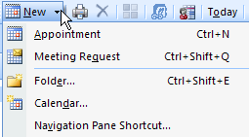  Type in the details, and time. Place and location are optional extras that can be used if you are going out of the office.  Tip: If you are having to travel, it is useful to make a separate appointment for travel time there and back. That way you will know when the meeting will start and finish. It also is useful when claiming km for travel and finding when and where you traveled to.
3 | Recurring appointment | 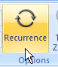  Appointments that happen more than once can be made to appear more than once by using the Recurrence button.  This is useful for making appointments that happen every week (staff meetings), every two weeks (assemblies), or birthdays every year.  Other options here allow you to set how often you want this appointment to recur, or when you want it to stop. This can be useful if you are visiting a class every day at the same time for a week, or if you want to book staff meetings into your calendar to the end of the year.  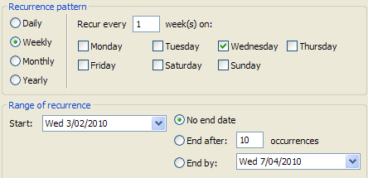
4 | Share your Calendar with others through Google Calendar | A very helpful tool is to share your calendar with others through google calendar. By creating a google account, you can then access the calendar feature.  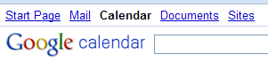  Then by selecting Sync, you can download a small application that will syncronise with your Outlook calendar. 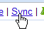  Follow the instructions.  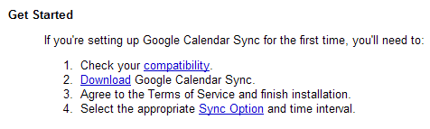  Once installed, you will see a little icon at the bottom right of your screen.  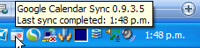  Set the sync option as two ways and at a 10 min interval (it will not work more often than this).  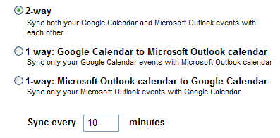  Once set up, your outlook calendar will sync with your google calendar. Every time you add something to your calendar in outlook, it will add to your online calendar. Vice versa, every time you (or someone else) add something to your online calendar, it will add it to your outlook calendar.  Why would you want to do this? Principals have many demands on their time, and many people wanting to have time with them. By sharing your online calendar with others, they can make appointments in your diary.  Eg the School secretary can access your calendar. If you are out of the school or just planned to be in a different part of the school, she will see it. if someone rings and wants an appointment to see you, she can book it in. if you want her to ring someone to come and see you, she can manage this. Believe it or not, by giving this job away, allowing others to make times in your diary for simple appointments, this frees up huge amounts of time. She can ensure the school calendar, especially important dates are all in the diary.  Deputy Principal – the DP is an importart person to allow access to your calendar. He/she can see what business you are doing, can make times for others to come and see you, or make time for them to come and see you!  Partners – often home life is a challenge juggling your night commitments with home life commitments. By allowing home to add things to your calendar, he/she can book nights they are out, or they need you before someone else beats you to it.
5 | How to share your google calendar with others | Once you have set up a google account, you will automatically have a calendar facility.  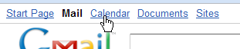  Click on settings  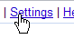  Click on Calendars  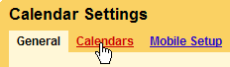  A list of calendars you have access to will appear. Choose the calendar you want to share with others.  To add people to your calendar, enter in their email address and choose what privledges you are giving them. If you want them to be able to add things to your diary, choose Make changes to events.  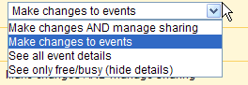  When they go to their own calendar, they will have the option of viewing your calendar. They can choose to look at just your calendar, or look at a range of calendars at the same time.  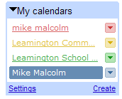
6 | OneNote meeting notes | 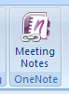  You can immediatley take notes and later organise these notes by selecting on Meeting Notes. This opens up a new page in OneNote. It means you can find notes you made at a meeting by simply searching your calendar.
7 | Appointments – colour coding | You can colour code appointments by using Categorize.  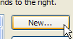  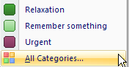  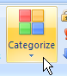  You can select from the options there, or you can customise these by selecting All Caeegories.then find the New button on the right of the screen. You can also delete options that you would not use.  It is useful to colour code things that are important, or if you are sharing your calendar with someone, to quickly draw their attention to something unusual – like if you are out of the office.

